**What is a Friend of BEACON?**

The Friends of BEACON are people keen to strengthen the network of support for BEACON’s work. They do one or more of the following:

* Receive regular information about our activities
* Circulate information about BEACON’s projects to increase understanding of the issues around asylum and the scope of our work
* Attend and publicise occasional local meetings and events involving asylum seekers and related to BEACON’s work
* Volunteer to support one of BEACON’s projects
* .
* Become involved in campaigns on asylum issues, e.g. by making a response by email or contacting their local councillor or Member of Parliament, and encouraging others to do so
* Become a trustee of BEACON
* Provide voluntary management support

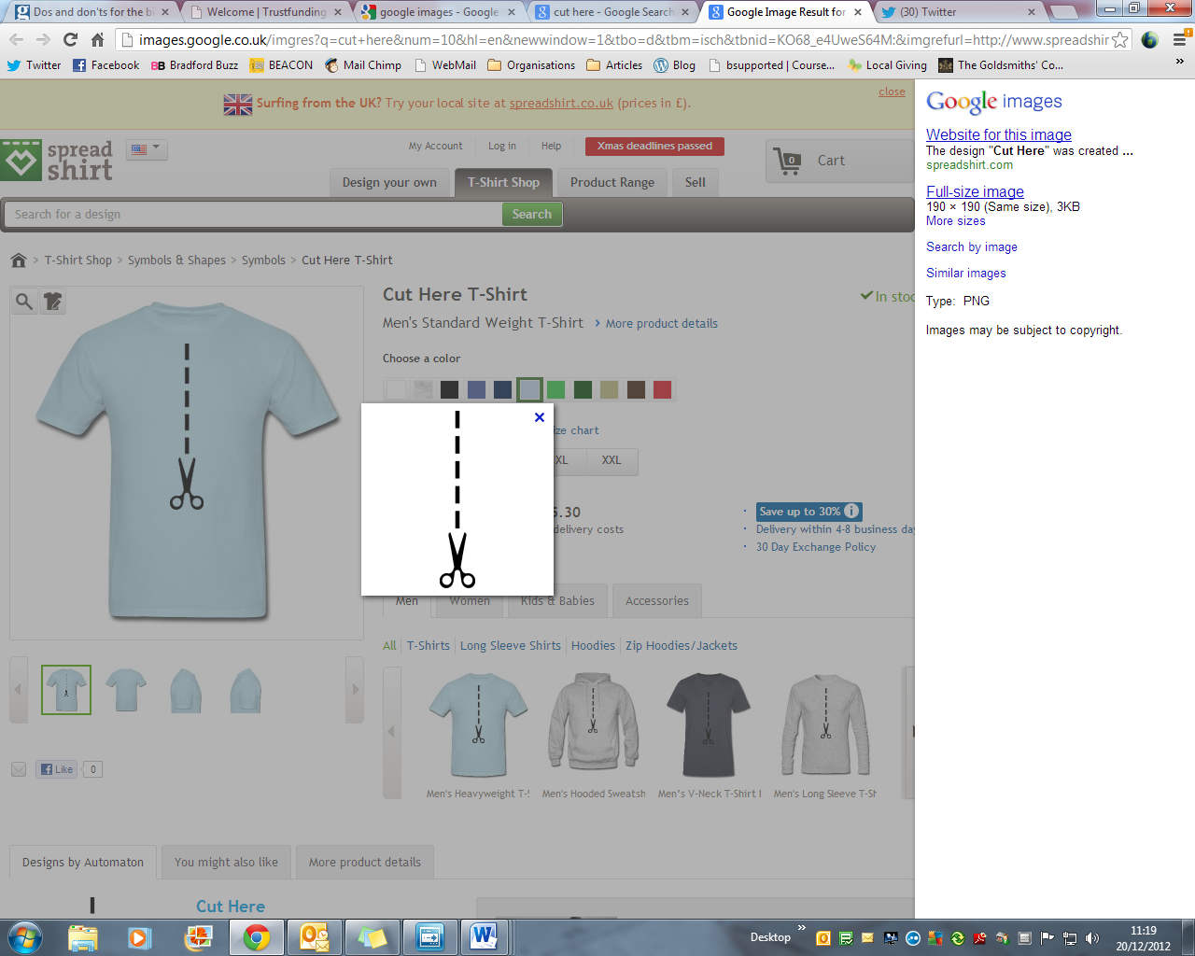**What will I get for becoming a friend of BEACON?**

* The knowledge that you are contributing to long-term solutions to the issues faced by asylum seekers in the UK.
* Invitations to events and free training
* Regular updates on our work by post or email
* Opportunities to support asylum seekers by volunteering with our projects or serving on the Executive committee.
* Access to resources to run study groups, prayer meetings and more!

**Will you become a friend of BEACON?**

If so, please complete the attached form and return it to;

**Katy Armitstead,**

**BEACON Team Leader**

**32 Merton Road**

**Bradford BD7 1RE**

**beacon@beaconbradford.org**

**01274 727525**



**Response Form**

***I want to support asylum seekers by becoming a Friend of BEACON***

Name:

Address:

Post Code:

Email:

Telephone:

***I am interested in:***

* McKenzie Friends
* CHAT
* Hosting

***I will commit to the following:***

* make a
* one-off eddonation

Gift Aid

* consider ing
* Other: please get in touch with any other ideas you have for supporting our work!

**Signature** \_\_\_\_\_\_\_\_\_\_\_\_\_\_\_\_\_\_\_\_

**Date** \_\_\_\_\_\_\_\_\_\_\_\_\_\_\_\_\_\_\_\_\_\_\_\_





**Friends of BEACON**

**BEACON Team Leader**

**32 Merton Road**

**Bradford**

**BD7 1RE**

**Help support asylum seekers in Bradford by becoming a friend of BEACON**



**About BEACON**

**s**



A McKenzie Friend is a ns. We will also

**a**

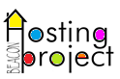

Our Hosting Project finds



bd19728_

***‘Welcome the Stranger’***

**www.beaconbradford.org**